Task 1: Resolve Merge Conflicts

Outcome
A Git merge conflict was intentionally created by modifying the same file on two branches. The conflict was resolved manually, committed, and pushed to GitHub.

Objective
To understand how Git identifies conflicting changes when two branches modify the same line of a file, and to resolve the conflict before completing the merge.

Prerequisites
- Windows operating system.
- Git for Windows and Git Bash terminal.
- A local Git repository connected to GitHub.
- Basic knowledge of Git branches, commits, and merging.
- Permission to push changes to the remote repository.

Step-by-Step Implementation

Step 1: Navigate to the Repository
Open Git Bash and navigate to the local repository.
cd ~/OneDrive/Desktop/git-test
git status
Ensure there are no uncommitted changes before starting.

Step 2: Create the First Branch
Create a branch and add content to a file.
git switch -c conflict-user1
echo "Welcome from User 1" > conflict.txt
git add conflict.txt
git commit -m "Add User 1 content"

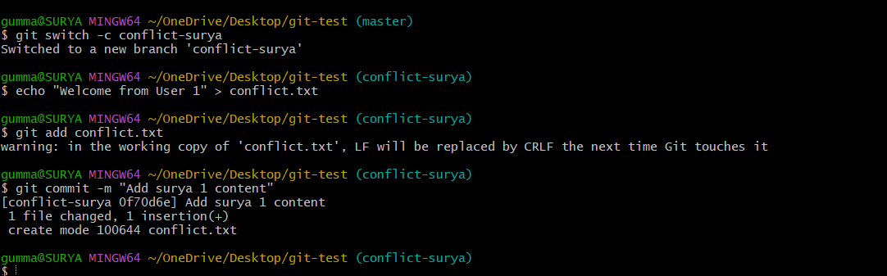

Step 3: Create the Second Branch
Switch to the main branch and create another branch.
git switch master
git switch -c conflict-user2
echo "Welcome from User 2" > conflict.txt
git add conflict.txt
git commit -m "Add User 2 content"
Both branches now contain different versions of conflict.txt.

Step 4: Create the Merge Conflict
Switch to the first branch and merge the second branch.
git switch conflict-user1
git merge conflict-user2
If Git reports a conflict, inspect the file:
cat conflict.txt
The file may contain conflict markers similar to:
<<<<<<< HEAD
Welcome from User 1
=======
Welcome from User 2
>>>>>>> conflict-user2
These markers identify the conflicting versions.
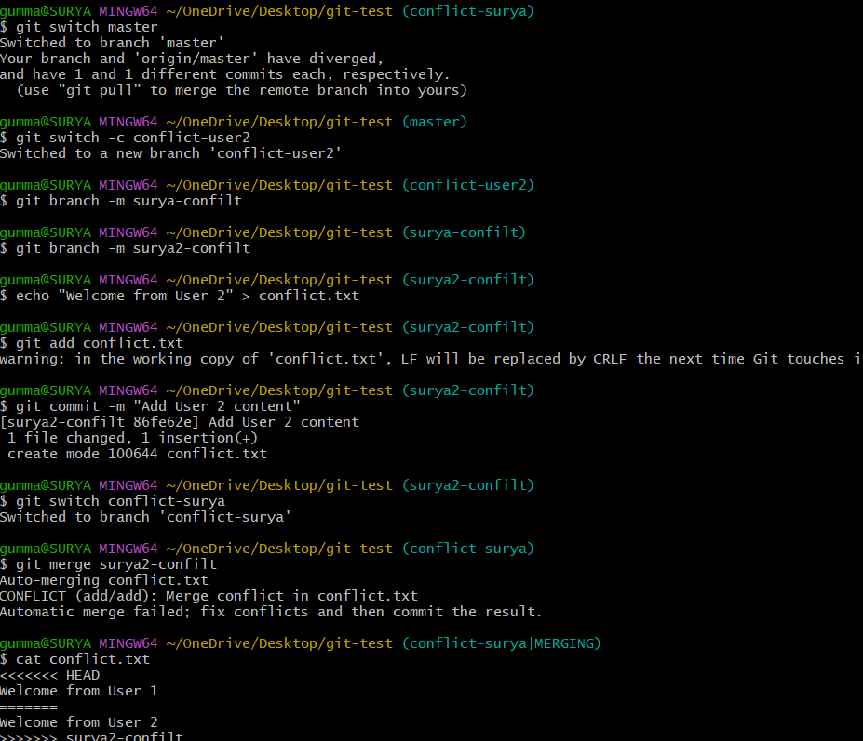

Step 5: Resolve the Conflict
Open conflict.txt in a text editor and replace the conflict markers and conflicting lines with the desired final content:
Welcome from User 1 and User 2
Save the file.
Stage and commit the resolution:
git add conflict.txt
git commit -m "Resolve merge conflict"

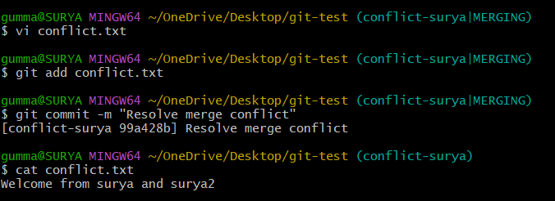

Step 6: Push the Resolved Branch to GitHub
git push -u origin conflict-user1
Open the repository on GitHub and verify that the conflict-user1 branch contains the resolved file.
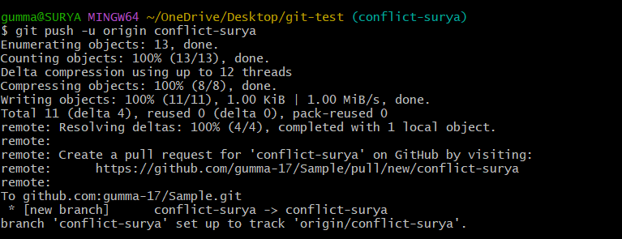
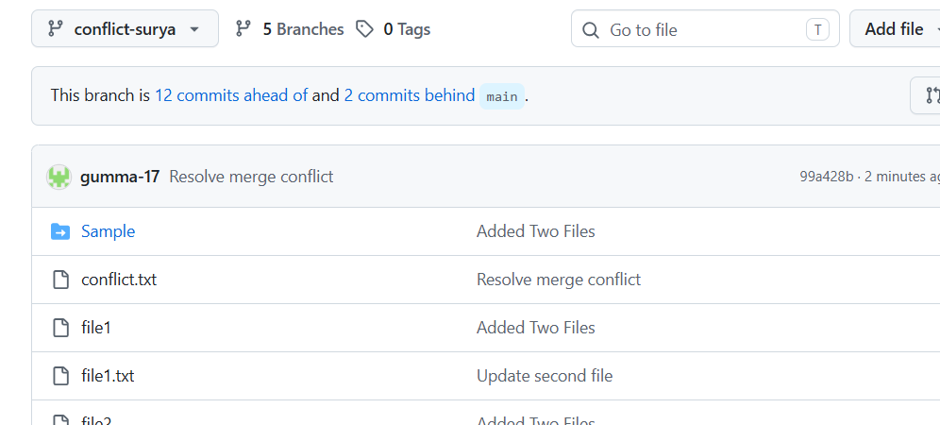

Validation Steps
No. | Test | Expected Result
1 | Run git branch | Both conflict branches are listed locally.
2 | Run git merge conflict-user2 from conflict-user1 | Git reports a conflict if the same line has incompatible changes.
3 | Inspect conflict.txt | Conflict markers identify the conflicting content.
4 | Run git status after editing | The file is shown as resolved after staging.
5 | Run git log --oneline -5 | The conflict-resolution commit appears in the history.
6 | Run git push -u origin conflict-user1 | The resolved branch is pushed successfully to GitHub.

Explanation
- git switch -c creates and switches to a new branch.
- git add stages changes for a commit.
- git commit saves changes in the local repository.
- git merge combines changes from another branch and may report conflicts.
- Conflict markers identify the competing versions of a file.
- git add marks the edited file as resolved.
- git push uploads the local branch and its commits to GitHub.

Real-Time Use Case
In software development, multiple developers may edit the same configuration file or source-code function on separate branches. Git identifies conflicting changes so the team can review and combine them correctly before merging the code.

Common Errors and Troubleshooting
Error | Possible Cause | Solution
CONFLICT (content) | Both branches changed the same section of a file. | Edit the file and resolve the conflicting content.
git commit fails during a merge | Conflicts remain unresolved or changes are not staged. | Resolve the files, then run git add on them.
git push is rejected | The remote branch has changes not present locally or permissions are insufficient. | Fetch or integrate remote changes and verify repository access.
pathspec did not match | The branch name or file path is incorrect. | Check names using git branch and ls.
Conflict markers remain in the file | The file was not fully cleaned up. | Remove all <<<<<<<, =======, and >>>>>>> markers before committing.

Conclusion
A merge conflict was created by making different changes to the same file on two branches. The conflicting content was reviewed and resolved manually, staged, committed, and pushed to GitHub. This practical demonstrates how Git supports collaboration while allowing developers to resolve incompatible changes safely.

Task 2: Recover a Deleted Branch Using Git Reflog

Outcome
A deleted local Git branch was recovered using the Git reflog, restoring access to its previous commit history.

Objective
To understand how Git reflog records recent changes to branch references and how it can be used to recover a deleted branch.

Prerequisites
- Windows operating system.
- Git for Windows and Git Bash terminal.
- A local Git repository.
- Basic knowledge of branches and commits.

Step-by-Step Implementation

Step 1: Navigate to the Repository
cd ~/OneDrive/Desktop/git-test
git status
Ensure that the working tree is clean.
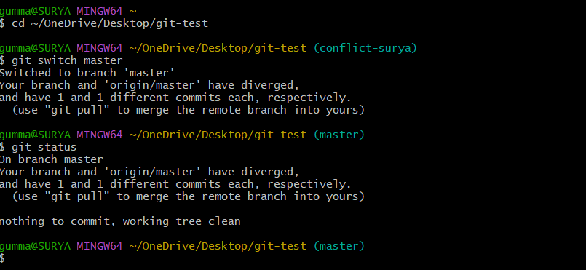

Step 2: Create a Branch and Commit a File
git switch -c recovery-branch
echo "Branch recovery test" > recovery.txt
git add recovery.txt
git commit -m "Add recovery file"

Step 3: Delete the Local Branch
Switch to another branch before deleting the test branch.
git switch master
git branch -D recovery-branch
The local branch is deleted, but its recent commit may still be recoverable through the reflog.
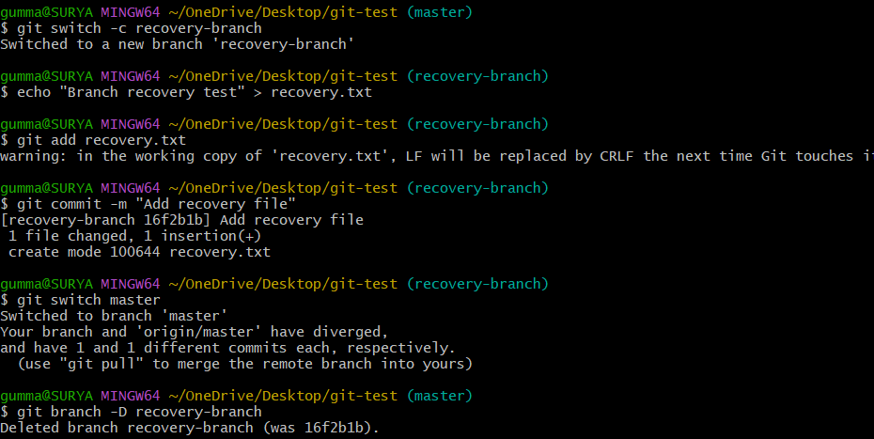

Step 4: Inspect the Reflog
git reflog
Find the entry associated with the Add recovery file commit and copy its commit hash.
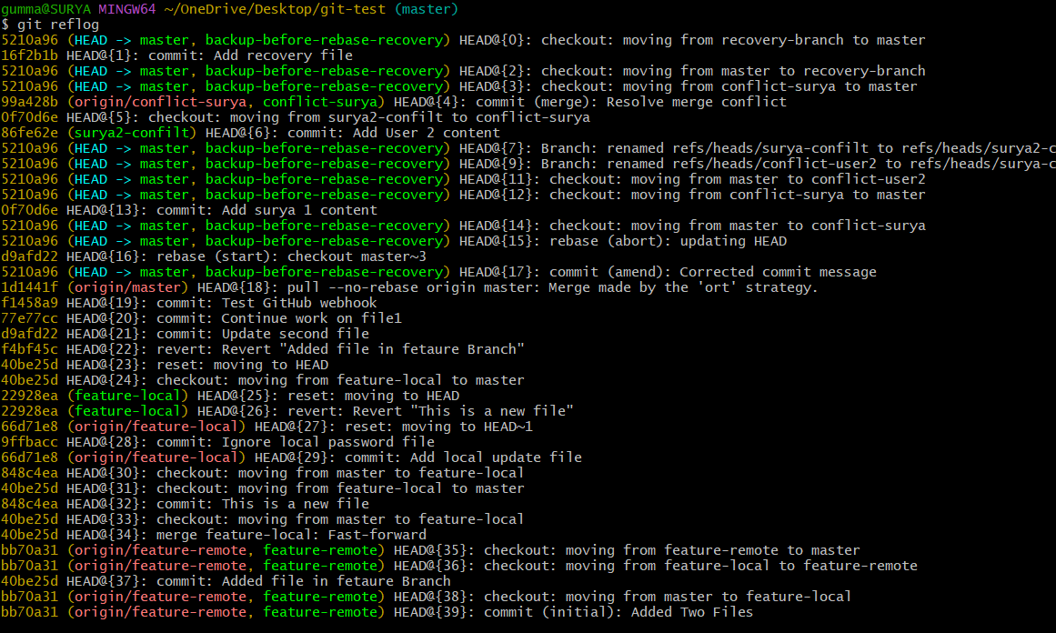

Step 5: Recover the Branch
Replace <commit-hash> with the actual hash from your reflog.
git branch recovery-branch <commit-hash>
git switch recovery-branch

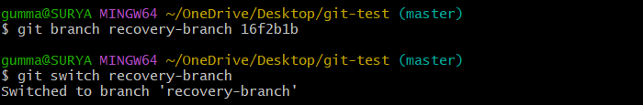

Step 6: Verify Recovery
git branch
git log --oneline -5
ls

The branch and its committed file should be available again.

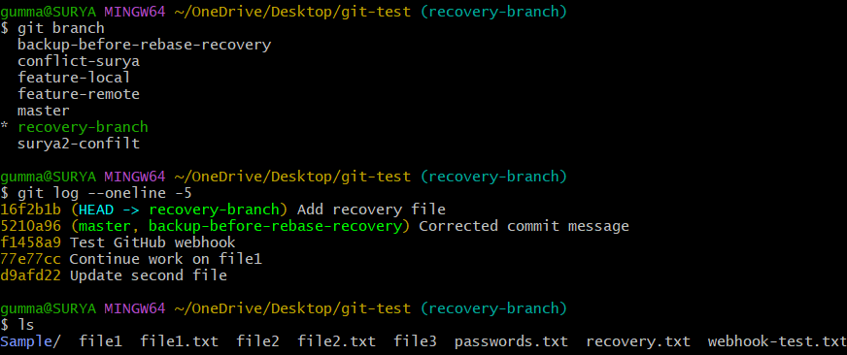

Validation Steps
No. | Test | Expected Result
1 | Run git branch -D recovery-branch | Local branch is deleted.
2 | Run git reflog | Recent branch and commit movements are displayed.
3 | Run git branch recovery-branch <commit-hash> | Branch is restored at the selected commit.
4 | Run git switch recovery-branch | The recovered branch becomes active.
5 | Run git log --oneline -5 | The recovery commit appears in history.

Explanation
git branch -D force-deletes a local branch reference.
git reflog records recent movements of references such as HEAD.
git branch creates a branch at a specified commit.
Git reflog is local to the repository and is not a substitute for a remote backup.

Real-Time Use Case
A developer accidentally deletes a feature branch before creating a pull request. The reflog can help locate the last commit and recreate the branch.

Common Errors and Troubleshooting
Error | Possible Cause | Solution
Commit hash not found | Incorrect hash copied from reflog | Copy the complete or correct abbreviated hash.
Branch already exists | A branch with that name is present | Inspect with git branch and choose an appropriate name.
Commit cannot be recovered | Reflog entry expired or object was removed | Check other branches, remotes, or backups.
Cannot delete the current branch | The branch is currently checked out | Switch to another branch first.

Conclusion
The deleted local branch was recovered by locating its commit through Git reflog and recreating the branch reference. This practical demonstrates how Git can help recover from accidental branch deletion.

Task 3: Undo a Wrong Push Without Losing History

Outcome
An incorrect change was pushed to GitHub and then undone using git revert, preserving the original commit in history.

Objective
To understand how to reverse an unwanted pushed commit without rewriting shared repository history.

Prerequisites
- Git and Git Bash installed.
- A GitHub repository connected to the local repository.
- Permission to push branches to GitHub.
- A clean working tree.

Step-by-Step Implementation

Step 1: Create a Test Branch
git switch -c wrong-push-test

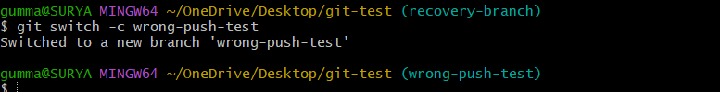

Step 2: Create an Incorrect Test Change
echo "Incorrect content" > wrong.txt
git add wrong.txt
git commit -m "Add incorrect content"

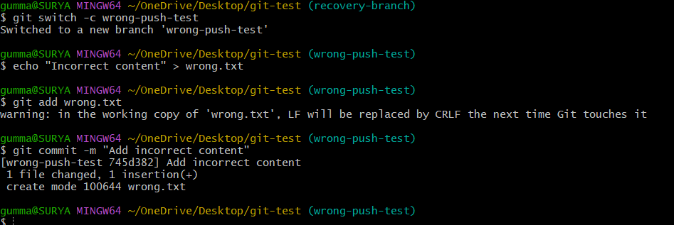

Step 3: Push the Commit to GitHub
git push -u origin wrong-push-test

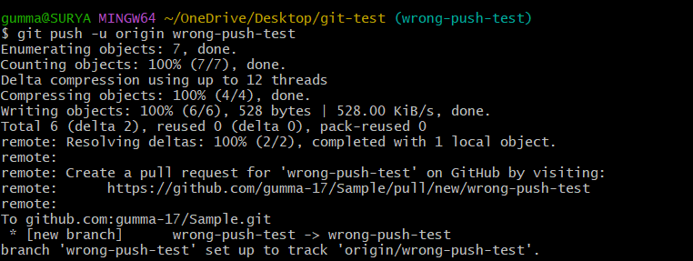

Step 4: Identify the Commit
git log --oneline -5
Copy the hash of the Add incorrect content commit.
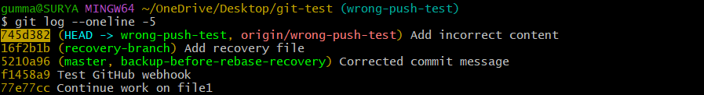

Step 5: Revert the Incorrect Commit
git revert <commit-hash>
Replace <commit-hash> with the actual hash. If the commit-message editor opens, save and close it. Git creates a new commit that reverses the earlier change.
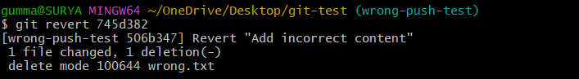

Step 6: Push the Revert Commit
git push origin wrong-push-test

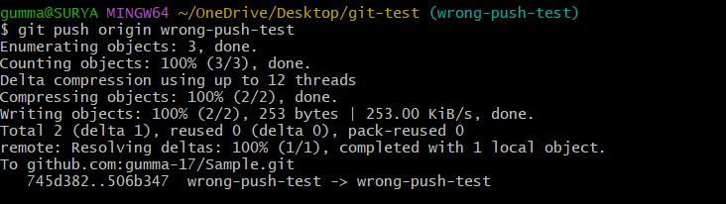

Step 7: Verify the History
git log --oneline -5
git status
The original commit and a newer revert commit should appear in the history.
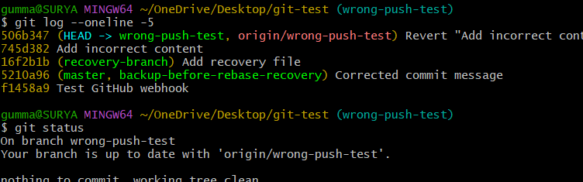

Validation Steps
No. | Test | Expected Result
1 | Run git push -u origin wrong-push-test | Test branch is pushed to GitHub.
2 | Run git revert <commit-hash> | A new commit reverses the selected commit.
3 | Run git log --oneline -5 | Original and revert commits remain visible.
4 | Push the branch again | Revert commit is uploaded successfully.
5 | Check the file and commit history | The unwanted content is undone while history is preserved.

Explanation
git commit records a change in local history.
git push sends commits to a remote repository.
git revert creates a new commit that reverses another commit.
Reverting is generally safer than force-pushing when other people may already have pulled the changes.

Real-Time Use Case
A developer accidentally pushes an incorrect configuration change to a shared branch. Reverting the change allows the team to undo it while retaining an auditable history.

Common Errors and Troubleshooting
Error | Possible Cause | Solution
Invalid revision | Incorrect commit hash | Copy the hash from git log --oneline.
Local changes would be overwritten | Uncommitted changes conflict with the revert | Commit or stash the changes first.
Push rejected | Remote branch has newer commits | Fetch and integrate remote changes before pushing.
Revert conflict | Later changes overlap with the reverted change | Resolve the files, stage them, and continue the revert.

Conclusion
An incorrect pushed commit was undone using git revert. The original commit remained in history, demonstrating a safe way to reverse unwanted changes in a shared repository.

Task 4: Amend a Commit to Add a Missing File

Outcome
A missing file was added to the latest commit using git commit --amend, avoiding the need for a separate additional commit.

Objective
To understand how to modify the latest commit by adding forgotten files and optionally changing the commit message.

Prerequisites
- Git and Git Bash installed.
- A local Git repository.
- A clean working tree.
- Basic knowledge of staging and committing files.

Step-by-Step Implementation

Step 1: Create a Test Branch
git switch -c amend-test

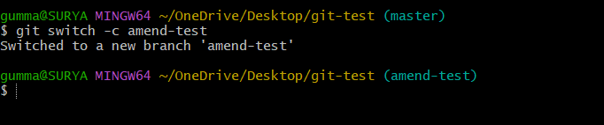

Step 2: Create and Commit the First File
echo "First file" > first.txt
git add first.txt
git commit -m "Add first file"

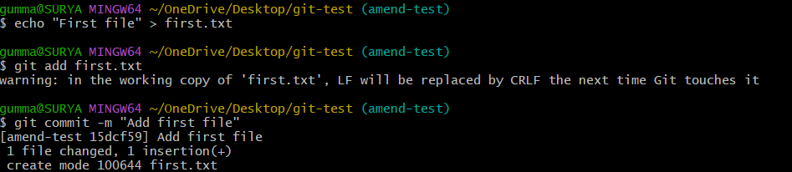

Step 3: Create the Missing File
echo "Second file" > second.txt
git add second.txt

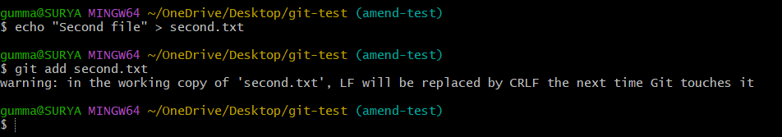

Step 4: Amend the Latest Commit
git commit --amend --no-edit
The new file is added to the latest commit, and its existing message is retained.
To change the commit message instead, use:
git commit --amend -m "Add first and second files"

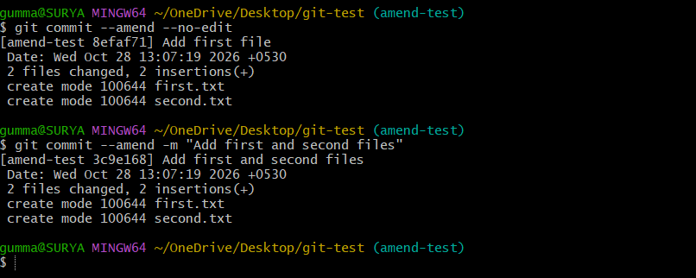

Step 5: Verify the Commit
git show --stat HEAD
git log --oneline -5
The latest commit should contain both files.
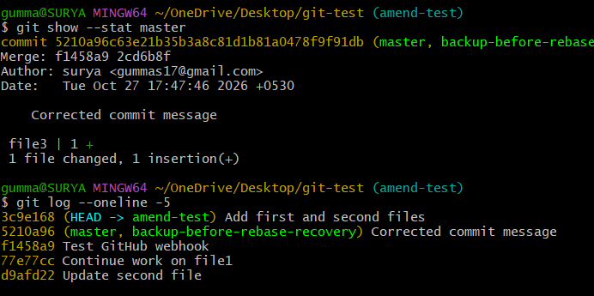

Validation Steps
No. | Test | Expected Result
1 | Commit first.txt | Initial commit is created.
2 | Stage second.txt | Missing file is staged.
3 | Run git commit --amend --no-edit | Latest commit is amended.
4 | Run git show --stat HEAD | Both files appear in the commit summary.
5 | Run git log --oneline -5 | Amended commit appears in history.

Explanation
git add stages file changes.
git commit --amend --no-edit updates the latest commit without changing its message.
git commit --amend -m updates the latest commit and sets a new message.
Amending rewrites the latest commit and changes its hash.

Real-Time Use Case
A developer commits source code but forgets to include a related configuration file. Amending the latest commit keeps the related changes together in one commit.

Common Errors and Troubleshooting
Error | Possible Cause | Solution
File missing from amended commit | File was not staged | Run git add <filename> before amending.
Nothing to amend | No new staged changes | Stage the missing file first.
Push rejected after amend | Remote contains the previous commit | Coordinate with collaborators before updating shared history.
Wrong commit amended | The intended commit is not the latest commit | Inspect git log before using amend.

Conclusion
The latest commit was amended to include a missing file. This practical demonstrates how Git can keep related changes together while maintaining a clean commit history.

Task 5: Cherry-pick a Commit

Outcome
A specific commit from one branch was applied to another branch using git cherry-pick.

Objective
To understand how to select an individual commit from one branch and apply its changes to another branch without merging the entire source branch.

Prerequisites
- Git and Git Bash installed.
- A local Git repository.
- At least one existing branch.
- Basic knowledge of commits and branches.

Step-by-Step Implementation

Step 1: Create the Source Branch
git switch -c cherry-source

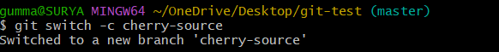

Step 2: Create a Commit
echo "Cherry-pick example" > cherry.txt
git add cherry.txt
git commit -m "Add cherry-pick file"

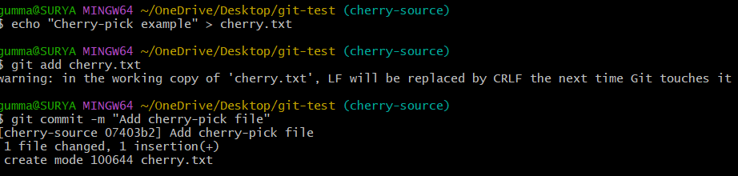

Step 3: Identify the Commit Hash
git log --oneline -1
Copy the hash of the Add cherry-pick file commit.

Step 4: Create the Target Branch
git switch master
git switch -c cherry-target

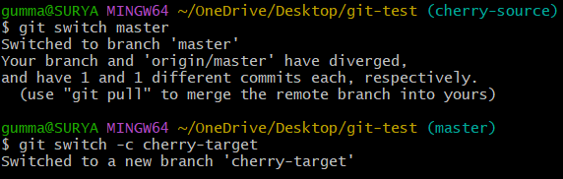

Step 5: Cherry-pick the Commit
git cherry-pick <commit-hash>
Replace the placeholder with the actual commit hash.
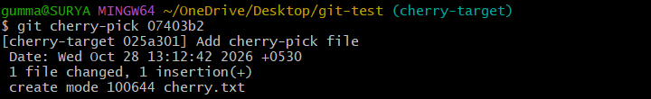

Step 6: Push the Target Branch
git push -u origin cherry-target

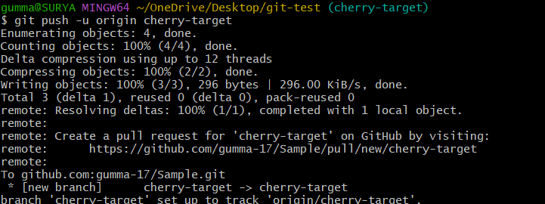

Step 7: Verify the Result
git log --oneline -5
ls
The target branch should contain cherry.txt and the cherry-picked change.
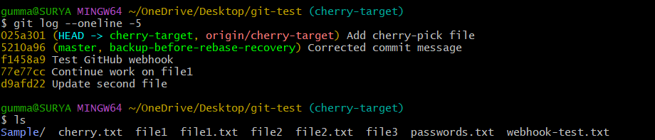

Validation Steps
No. | Test | Expected Result
1 | Create a commit on cherry-source | Source commit is created.
2 | Switch to cherry-target | Target branch becomes active.
3 | Run git cherry-pick <commit-hash> | Selected changes are applied to the target branch.
4 | Run git log --oneline -5 | Cherry-picked commit appears in the target history.
5 | Push the target branch | Branch is available on GitHub.

Explanation
git switch -c creates and switches to a branch.
git log --oneline displays short commit history.
git cherry-pick applies the changes introduced by a selected commit to the current branch.
Cherry-picking normally creates a new commit with a different hash from the source commit.

Real-Time Use Case
A developer fixes a critical bug on a development branch and needs the same fix on a maintenance branch. Cherry-picking transfers the specific fix without merging unrelated development work.

Common Errors and Troubleshooting
Error | Possible Cause | Solution
Invalid commit reference | Incorrect hash | Copy the hash from the source branch's log.
Cherry-pick conflict | Changes overlap with target-branch changes | Resolve the conflict, stage the files, and run git cherry-pick --continue.
Empty cherry-pick | The change is already present | Inspect the history and follow Git's suggested instructions.
Push rejected | Remote branch has new commits | Integrate remote changes and retry.

Conclusion
A selected commit was applied to another branch using cherry-pick. This practical demonstrates how individual changes can be transferred between branches without merging all source-branch commits.

Task 6: Interactive Rebase

Outcome
Multiple commits were reordered or combined into a single commit using interactive rebase.

Objective
To understand how interactive rebase helps organize local commit history before sharing changes with others.

Prerequisites
- Git and Git Bash installed.
- A local Git repository.
- A test branch with multiple commits.
- Basic knowledge of commits and branches.

Step-by-Step Implementation

Step 1: Create a Test Branch

git switch -c rebase-test
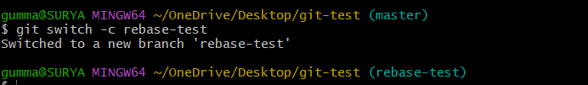

Step 2: Create Three Commits
echo "One" > one.txt
git add one.txt
git commit -m "Add first file"

echo "Two" > two.txt
git add two.txt
git commit -m "Add second file"

echo "Three" > three.txt
git add three.txt
git commit -m "Add third file"

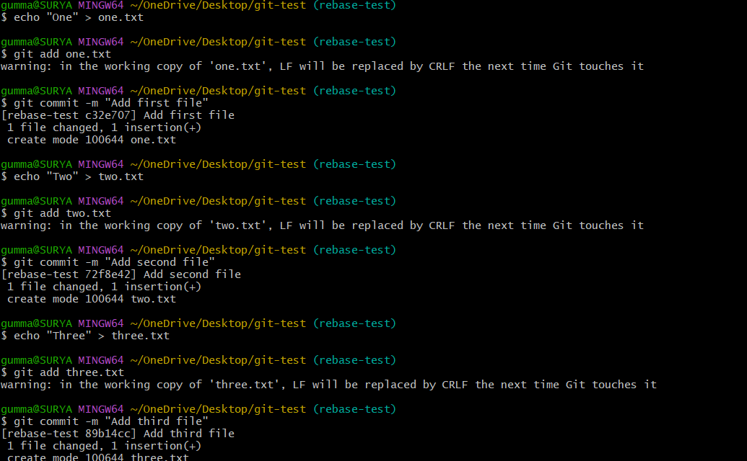

Step 3: Start Interactive Rebase
git rebase -i HEAD~3
The editor displays the last three commits. Keep the oldest commit as pick and change the next two commands to squash or s.
Example:
pick abc1234 Add first file
squash def5678 Add second file
squash ghi9012 Add third file
The hashes are examples only; use the actual lines shown in your editor.
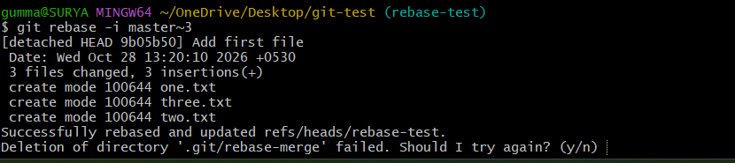

Step 4: Save the Instructions
Save and close the editor. Git will ask you to create a combined commit message.
Enter a message such as:
Add three practice files
Save and close the message editor.

Step 5: Verify the Rewritten History
git log --oneline -5
git show --stat HEAD
The three commits should now be represented by one combined commit on this branch.
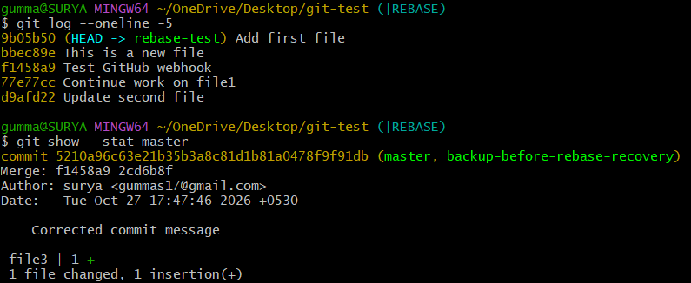

Validation Steps
No. | Test | Expected Result
1 | Create three separate commits | Three commits appear in the history.
2 | Run git rebase -i HEAD~3 | Interactive rebase editor opens.
3 | Mark the second and third commits as squash | Git combines the commits.
4 | Save the combined message | Rebase completes successfully.
5 | Run git log --oneline -5 | A single combined commit replaces the three commits on the branch.

Explanation
git rebase -i opens an interactive history editor.
pick retains a commit.
squash combines a commit with the preceding picked commit and allows message editing.
Interactive rebase rewrites commit history and creates new commit hashes.

Real-Time Use Case
Before submitting a pull request, a developer combines small corrective commits into a clean, meaningful commit history for easier code review.

Common Errors and Troubleshooting
Error | Possible Cause | Solution
Invalid upstream | Not enough commits exist | Check git log --oneline and choose a valid range.
Rebase conflict | Commit changes overlap | Resolve conflicts, stage the files, and run git rebase --continue.
Rebase editor does not save | Incorrect editor commands | Save and close the configured editor correctly.
History differs from remote | Rebase changed published commits | Avoid rewriting shared history without coordinating with collaborators.

Conclusion
Interactive rebase was used to combine multiple commits into a single commit. This practical demonstrates how developers can prepare a clearer and more organized history before submitting changes.

Task 7: Tagging and Release

Outcome
A version tag named v1.0 was created, pushed to GitHub, deleted, and restored.

Objective
To understand how Git tags identify specific commits and how version tags can be managed locally and remotely.

Prerequisites
- Git and Git Bash installed.
- A GitHub repository with at least one commit.
- Permission to push to the repository.
- Basic knowledge of commits and version control.

Step-by-Step Implementation

Step 1: Switch to the Main Branch
git switch master
Ensure that you have selected the commit you want to tag.
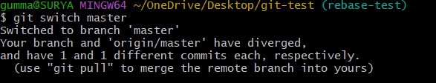

Step 2: Create an Annotated Tag
git tag -a v1.0 -m "Version 1.0 release"

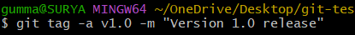

Step 3: Push the Tag to GitHub
git push origin v1.0

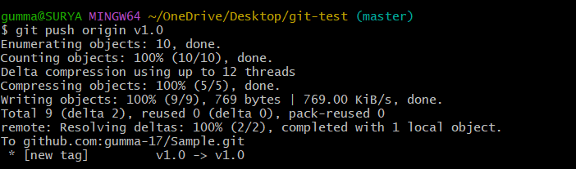

Step 4: Verify the Tag
git tag
git show v1.0
Open the repository on GitHub and inspect its tags.
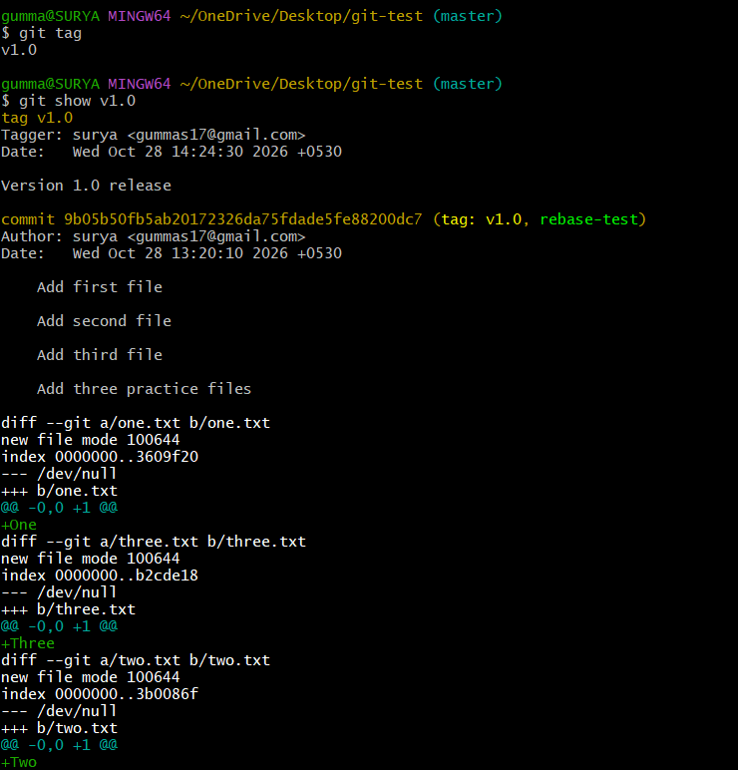

Step 5: Delete the Tag
Delete the local tag:
git tag -d v1.0
Delete the remote tag:
git push origin --delete v1.0

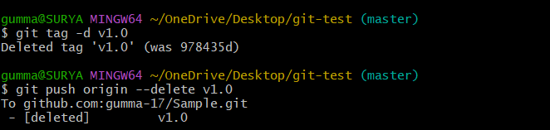

Step 6: Restore the Tag
Identify the original commit hash using your saved notes or commit history.
git tag -a v1.0 <original-commit-hash> -m "Version 1.0 release"
git push origin v1.0
Replace the placeholder with the original tagged commit's actual hash.
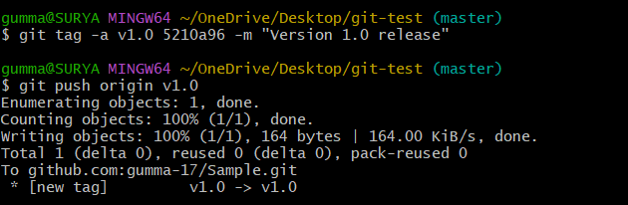

Step 7: Verify the Restored Tag
git show v1.0
git ls-remote --tags origin
The tag should again be present locally and remotely.
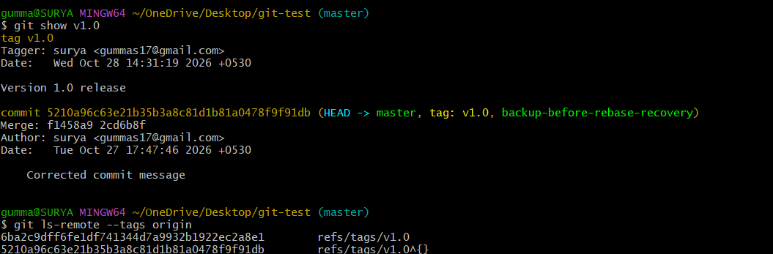

Validation Steps
No. | Test | Expected Result
1 | Run git tag -a v1.0 -m "Version 1.0 release" | Annotated tag is created.
2 | Run git push origin v1.0 | Tag is uploaded to GitHub.
3 | Delete the local and remote tag | Tag is removed from both locations.
4 | Recreate the tag at the original commit | Local tag is restored.
5 | Push the restored tag | Tag reappears on GitHub.

Explanation
git tag -a creates an annotated tag.
git push origin v1.0 pushes a specific tag.
git tag -d deletes a local tag.
git push origin --delete v1.0 deletes the remote tag.
Tags are commonly used to identify release versions.

Real-Time Use Case
A software team tags a stable application version as v1.0 so that developers and deployment pipelines can identify the exact release commit.

Common Errors and Troubleshooting
Error | Possible Cause | Solution
Tag already exists | The tag name is already in use | Inspect with git tag before creating it.
Remote tag deletion fails | Incorrect remote or insufficient permission | Verify origin and repository access.
Restored tag points to the wrong commit | Incorrect commit hash selected | Verify the original commit before recreating the tag.
Tag is missing on GitHub | Tag was not pushed | Run git push origin v1.0.

Conclusion
A version tag was created, pushed, deleted, and restored. This practical demonstrates how Git tags identify release points and support version management.

Task 8: Clone with Sparse Checkout

Outcome
A repository was cloned using sparse checkout so that only a selected subdirectory appeared in the working tree.

Objective
To understand how sparse checkout limits the files checked out from a repository, reducing the working-tree contents when working with large projects.

Prerequisites
- Git for Windows and Git Bash installed.
- Internet connection.
- Access to a GitHub repository.
- A repository containing a directory such as docs.

Step-by-Step Implementation

Step 1: Choose a Repository
Choose a repository that contains the directory you want to work with. In the commands below, replace OWNER/REPO with the actual owner and repository name.

Step 2: Clone with Sparse Checkout
git clone --filter=blob:none --sparse https://github.com/OWNER/REPO.git sparse-demo
This command creates a clone with sparse checkout enabled and requests blob filtering.

Step 3: Enter the Repository
cd sparse-demo

Step 4: Select a Subdirectory
git sparse-checkout set docs
The docs directory is selected for checkout. It must exist in the repository.

Step 5: Verify the Selection
git sparse-checkout list
ls
git status

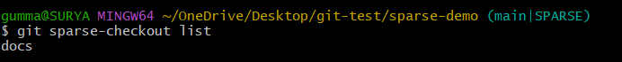
The sparse-checkout list should show docs, and the working tree should contain the selected directory.

Validation Steps
No. | Test | Expected Result
1 | Clone with --sparse | Repository is cloned with sparse checkout enabled.
2 | Run git sparse-checkout set docs | The selected directory is checked out.
3 | Run git sparse-checkout list | The selected directory is displayed.
4 | Run ls | The working tree shows the selected directory and any other included root-level files.
5 | Run git status | Repository status is displayed without errors.

Explanation
git clone creates a local copy of a repository.
--sparse enables sparse checkout.
--filter=blob:none requests that file contents be fetched as needed rather than downloading all blobs immediately.
git sparse-checkout set defines which paths should appear in the working tree.

Real-Time Use Case
A developer working in a large monorepo may need only the documentation or a specific application directory. Sparse checkout reduces the number of files present in the working tree.

Common Errors and Troubleshooting
Error | Possible Cause | Solution
Repository not found | Incorrect URL or insufficient access | Verify the repository URL and permissions.
Path not found | Selected directory does not exist | Check the repository directory structure.
Sparse checkout command fails | Older Git version | Update Git for Windows.
Other files are still visible | Root-level files or previously selected paths remain included | Inspect git sparse-checkout list and the sparse-checkout configuration.

Conclusion
Sparse checkout was configured to include a selected subdirectory of a repository. This practical demonstrates how developers can limit working-tree contents when working with large projects.

Task 9: Reset vs Revert Challenge

Outcome
The effects of git reset --hard and git revert were demonstrated on separate test branches to compare their impact on history and file contents.

Objective
To understand the difference between moving a branch reference backward with reset and creating a new commit that reverses an earlier change with revert.

Prerequisites
- Git and Git Bash installed.
- A local repository.
- Basic knowledge of branches and commits.
- A clean working tree.
- A separate practice branch to prevent accidental loss of important work.

Step-by-Step Implementation

Step 1: Create a Reset Test Branch
git switch -c reset-demo

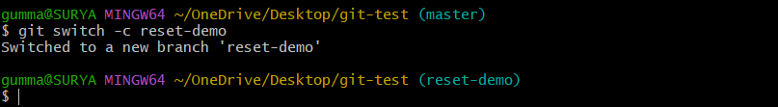

Step 2: Create Two Commits
echo "First" > reset.txt
git add reset.txt
git commit -m "First reset demo commit"

echo "Second" >> reset.txt
git add reset.txt
git commit -m "Second reset demo commit"

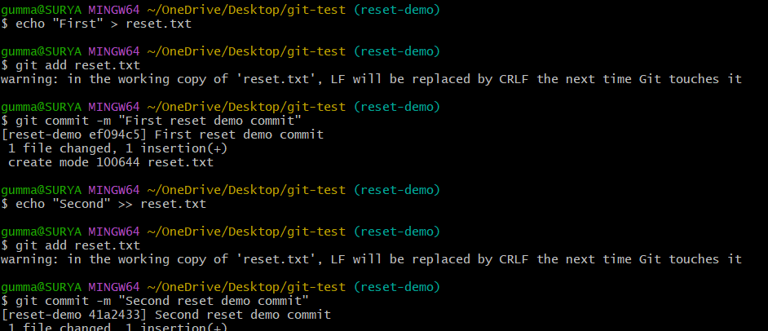

Step 3: Inspect the History
git log --oneline -3
cat reset.txt

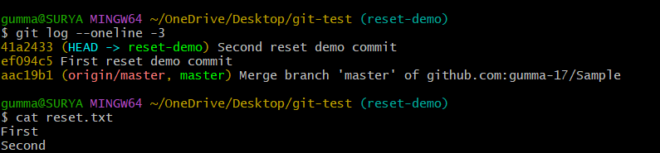

Step 4: Perform a Hard Reset
git reset --hard HEAD~1
This moves the current branch back by one commit and resets tracked files to match that commit.
Verify:
git log --oneline -3
cat reset.txt
The second commit should no longer be at the branch tip.
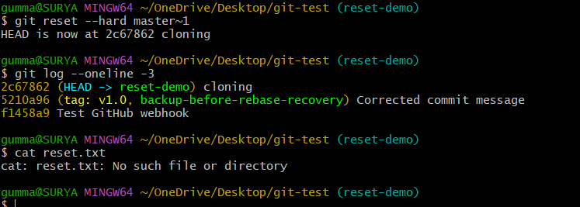

Step 5: Create a Separate Revert Test Branch
git switch master
git switch -c revert-demo
Create two commits:
echo "First" > revert.txt
git add revert.txt
git commit -m "First revert demo commit"

echo "Second" >> revert.txt
git add revert.txt
git commit -m "Second revert demo commit"

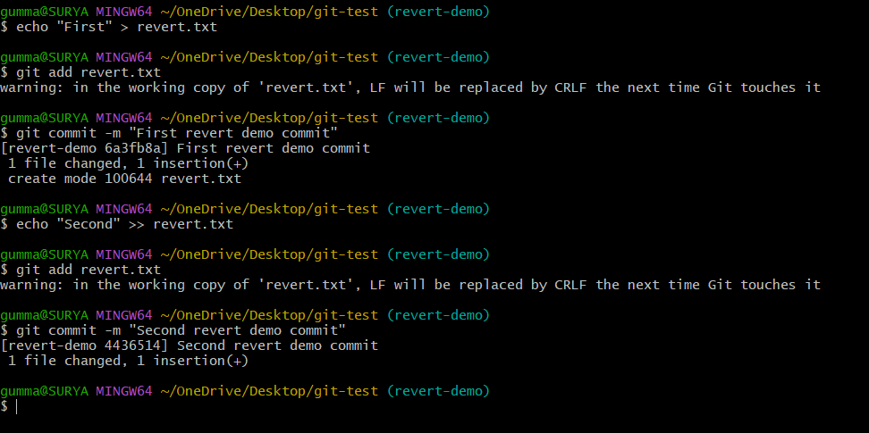

Step 6: Revert the Latest Commit
git revert HEAD
Save and close the commit-message editor if it opens.
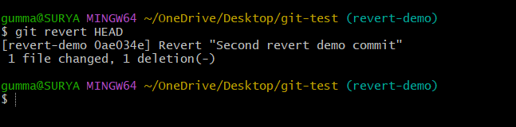

Step 7: Compare the Results
git log --oneline -5
cat revert.txt
The revert branch should show a new revert commit, while the reset branch no longer has its second commit at the branch tip.
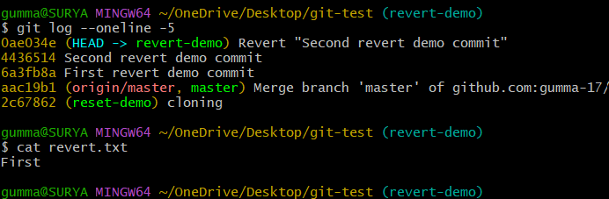

Validation Steps
No. | Test | Expected Result
1 | Create two commits on reset-demo | Two commits appear in history.
2 | Run git reset --hard HEAD~1 | Branch moves to the previous commit and tracked changes are reset.
3 | Run git revert HEAD on revert-demo | A new commit reverses the latest change.
4 | Run git log --oneline -5 | Reset and revert histories show different results.
5 | Inspect the files | File contents reflect the respective operation.

Explanation
git reset --hard moves the current branch to a specified commit and resets tracked working-tree files and the index.
git revert creates a new commit that reverses the effect of an earlier commit.
Reset can rewrite local branch history.
Revert is generally safer for changes that have already been shared.

Real-Time Use Case
A developer may use reset to discard an experimental local commit that has not been shared. For a wrong commit already pushed to a shared branch, revert is generally preferred because it preserves history.

Common Errors and Troubleshooting
Error | Possible Cause | Solution
Important changes disappear | reset --hard discarded tracked working-tree changes | Check reflog or backups; avoid hard reset on uncommitted work.
Revert conflict occurs | The change overlaps with later edits | Resolve the conflict, stage the files, and continue as instructed by Git.
Cannot switch branches | Working-tree changes would be overwritten | Commit or stash changes first.
Reset branch differs from remote | Local history was moved backward | Do not force-push shared history without understanding the consequences.

Conclusion
The reset and revert operations were compared on separate branches. Reset moved the branch reference backward and discarded tracked changes, while revert created a new commit that reversed an earlier change.

Task 10: Detached HEAD Challenge

Outcome
A specific commit was checked out in detached HEAD state, and a new branch was created from that commit to preserve subsequent work.

Objective
To understand detached HEAD state and learn how to create a branch when work needs to continue from a historical commit.

Prerequisites
Git and Git Bash installed.
A local repository with multiple commits.
Basic knowledge of commits and branches.

Step-by-Step Implementation

Step 1: Inspect the Commit History
git log --oneline -10
Choose the hash of a commit you want to inspect.
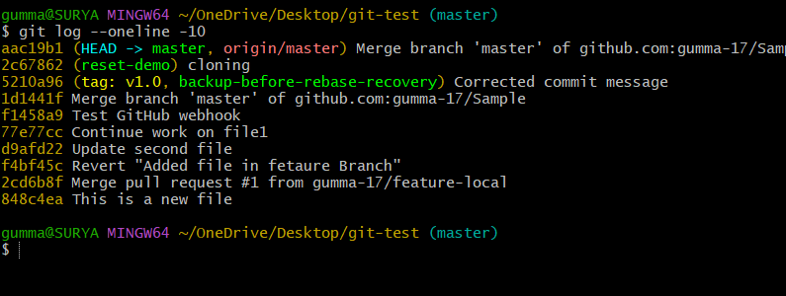

Step 2: Check Out the Specific Commit
git switch --detach <commit-hash>
Replace <commit-hash> with the actual commit hash.

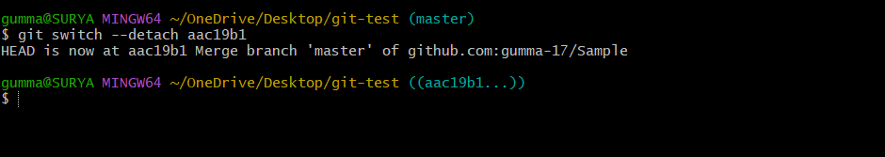

Step 3: Verify Detached HEAD State
git status
Git should indicate that HEAD is detached.
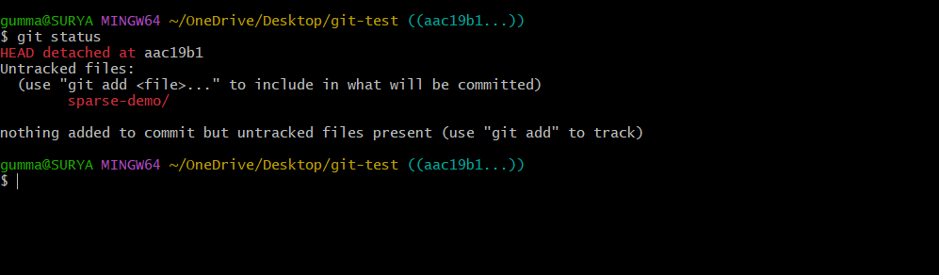

Step 4: Create a Branch
git switch -c detached-recovery
The new branch starts at the selected commit.
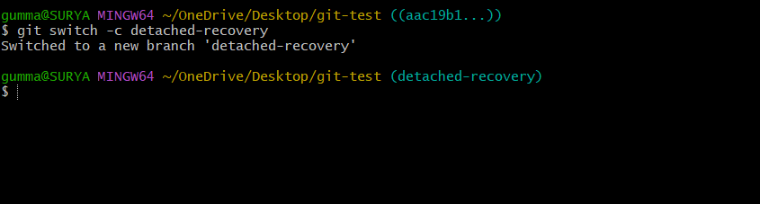

Step 5: Make a Test Commit
echo "Created from detached HEAD" > detached.txt
git add detached.txt
git commit -m "Add detached HEAD test file"

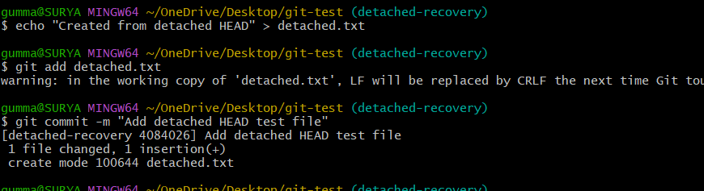

Step 6: Verify the Branch and Commit
git branch
git log --oneline -5
The new commit should be attached to detached-recovery.
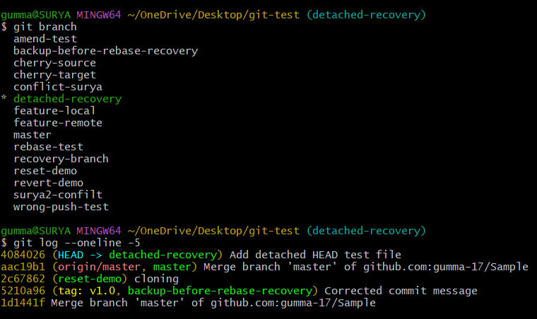

Validation Steps
No. | Test | Expected Result
1 | Run git log --oneline -10 | Recent commits are displayed.
2 | Run git switch --detach <commit-hash> | HEAD moves to the selected commit without attaching to a branch.
3 | Run git status | Detached HEAD state is reported.
4 | Run git switch -c detached-recovery | A new branch is created from that commit.
5 | Create and inspect a commit | New work is saved on the new branch.

Explanation
git switch --detach checks out a commit without moving a named branch.
Detached HEAD allows inspection or temporary experimentation.
git switch -c creates a branch at the current commit and switches to it.
Creating a branch helps preserve new commits made from detached HEAD.
Real-Time Use Case
A developer needs to inspect an older release or test a historical bug. Detached HEAD allows inspection of that commit, and a new branch can preserve any follow-up fixes.

Common Errors and Troubleshooting
Error | Possible Cause | Solution
Invalid reference | Incorrect commit hash | Copy the hash from git log.
Work is lost after switching | Commits were made in detached HEAD and no branch points to them | Use reflog to find the commit and create a branch.
Branch already exists | The branch name is already in use | Select another branch name or inspect the existing branch.
Cannot switch due to changes | Working-tree changes would be overwritten | Commit or stash changes before switching.

Conclusion
A historical commit was checked out in detached HEAD state, and a branch was created from it. This practical demonstrates how to inspect earlier versions and preserve additional work safely.

Task 11: Git Hooks Challenge

Outcome
A local commit-msg hook was configured to reject commit messages that do not begin with a JIRA-style issue identifier.

Objective
To understand how Git hooks can enforce a consistent commit-message format before a commit is accepted.

Prerequisites
Git for Windows and Git Bash installed.
A local Git repository.
Permission to create files in the repository's .git/hooks directory.
Basic knowledge of commit messages.

Step-by-Step Implementation

Step 1: Navigate to the Repository
git status

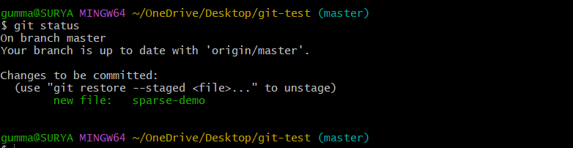

Step 2: Create the Commit Message Hook
In Git Bash, run:
cat > .git/hooks/commit-msg <<'EOF'
#!/bin/sh

message_file="$1"
message=$(head -n 1 "$message_file")

if printf '%s\n' "$message" | grep -Eq '^JIRA-[0-9]+([[:space:]]|$)'; then
exit 0
fi

echo "ERROR: Commit message must start with JIRA-123 format."
exit 1
EOF
This hook checks that the first line begins with JIRA- followed by one or more digits and a space or the end of the line.
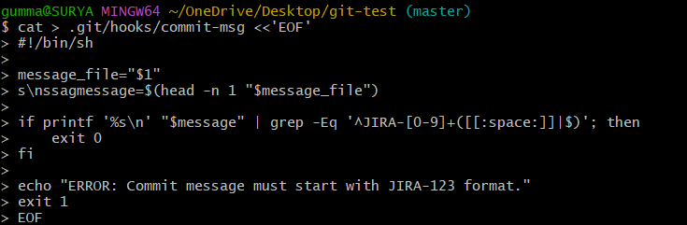

Step 3: Make the Hook Executable
chmod +x .git/hooks/commit-msg

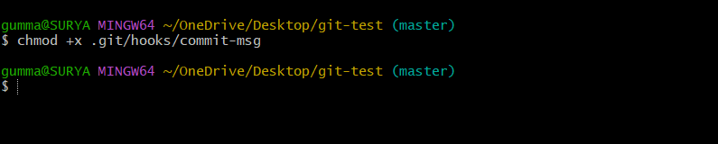

Step 4: Test an Invalid Commit Message
echo "Hook test" > hook.txt
git add hook.txt
git commit -m "Add hook test"
The hook should reject this commit message.
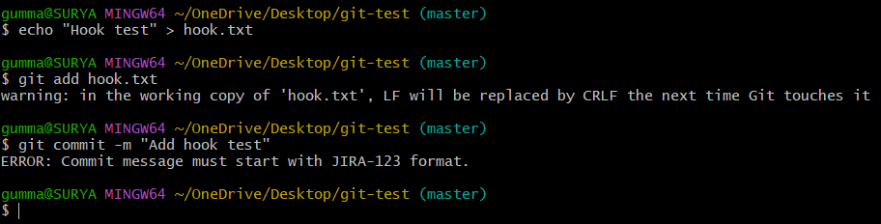

Step 5: Test a Valid Commit Message
git commit -m "JIRA-123 Add hook test"
The commit should succeed.
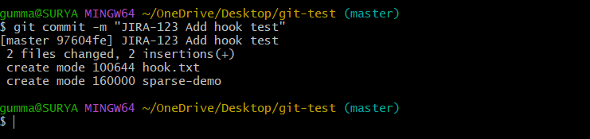

Step 6: Verify the Commit
git log --oneline -5
The valid commit should appear in the history.
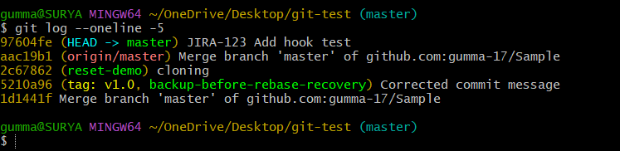

Validation Steps
No. | Test | Expected Result
1 | Create the commit-msg hook | Hook file is created.
2 | Run chmod +x .git/hooks/commit-msg | Hook becomes executable in Git Bash.
3 | Commit with Add hook test | Commit is rejected.
4 | Commit with JIRA-123 Add hook test | Commit succeeds.
5 | Run git log --oneline -5 | Valid commit appears in history.

Explanation
.git/hooks/commit-msg is a hook that validates the proposed commit message.
$1 is the path to the temporary file containing the commit message.
grep -E evaluates the specified extended regular expression.
Exit code 0 allows the commit to continue; a nonzero exit code rejects it.
Local hooks are not automatically distributed to other clones by pushing the repository.

Real-Time Use Case
Development teams often require commit messages to reference an issue or ticket. A commit-message hook can help enforce a format such as JIRA-123 Fix login validation.

Common Errors and Troubleshooting
Error | Possible Cause | Solution
Hook does not execute | Hook file has incorrect name or permissions | Confirm the file is named commit-msg and is executable.
Valid message is rejected | Message does not match the required pattern | Use a format such as JIRA-123 Fix bug.
Hook file not found | Incorrect repository directory | Check the path using git rev-parse --git-path hooks.
Hook is absent on another computer | Local hooks are not transferred by normal pushes | Use a shared hook-management solution or CI validation.

Conclusion
A Git commit-message hook was configured and tested. It rejected an invalid message and accepted a message with the required JIRA-style identifier, demonstrating how Git hooks support consistent development practices.

Task 12: Squash Merge vs Rebase Merge

Outcome
Squash merge and rebase merge were compared using separate test branches and pull requests, demonstrating their different effects on commit history.

Objective
To understand how GitHub's squash merge combines pull-request changes into one commit and how rebase merge preserves individual commits while applying them to the base branch.

Prerequisites
- Git and Git Bash installed.
- A GitHub repository with a base branch such as master.
- Permission to create branches and pull requests.
- Repository settings that allow the merge strategies being tested.

Step-by-Step Implementation

Step 1: Create a Branch for Squash Merge
git switch -c squash-demo

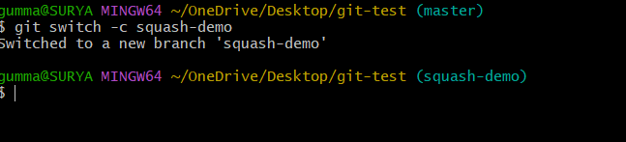

Step 2: Create Multiple Commits
echo "First squash change" > squash1.txt
git add squash1.txt
git commit -m "Add first squash file"

echo "Second squash change" > squash2.txt
git add squash2.txt
git commit -m "Add second squash file"

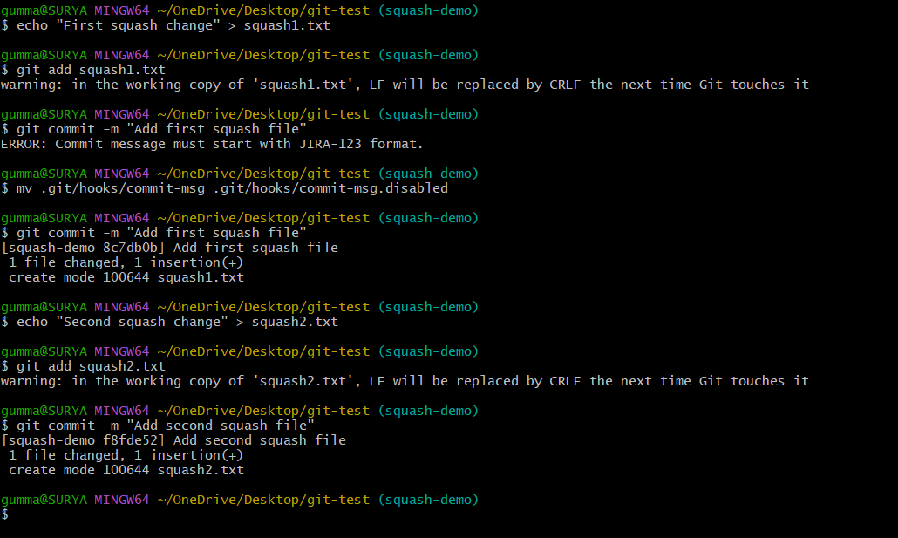

Step 3: Push the Branch
git push -u origin squash-demo

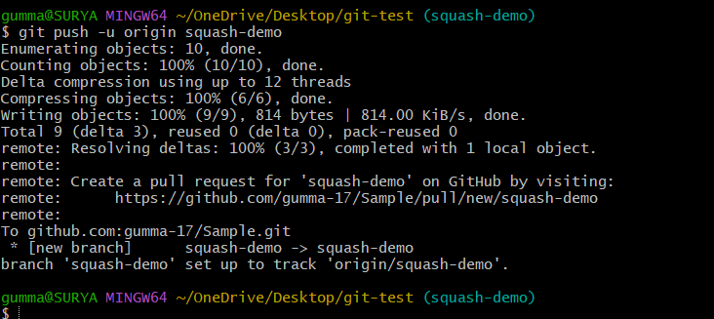

Step 4: Create and Squash-Merge a Pull Request
On GitHub:
Open the repository.
Create a pull request from squash-demo into master.
Review the changes.
Select Squash and merge, if enabled.
Confirm the merge.
The pull request's changes should appear as one combined commit on the base branch.
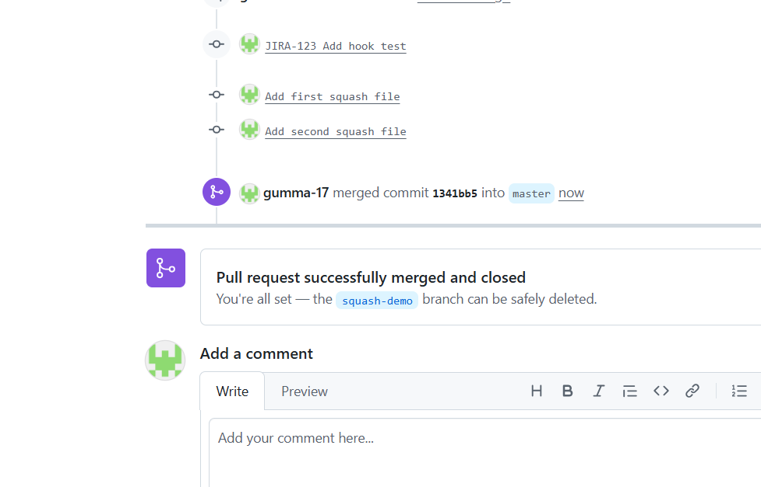

Step 5: Create a Separate Branch for Rebase Merge
After updating your local base branch, create another branch:
git switch master
git pull origin master
git switch -c rebase-merge-demo
Create two commits:
echo "First rebase change" > rebase1.txt
git add rebase1.txt
git commit -m "Add first rebase file"

echo "Second rebase change" > rebase2.txt
git add rebase2.txt
git commit -m "Add second rebase file"

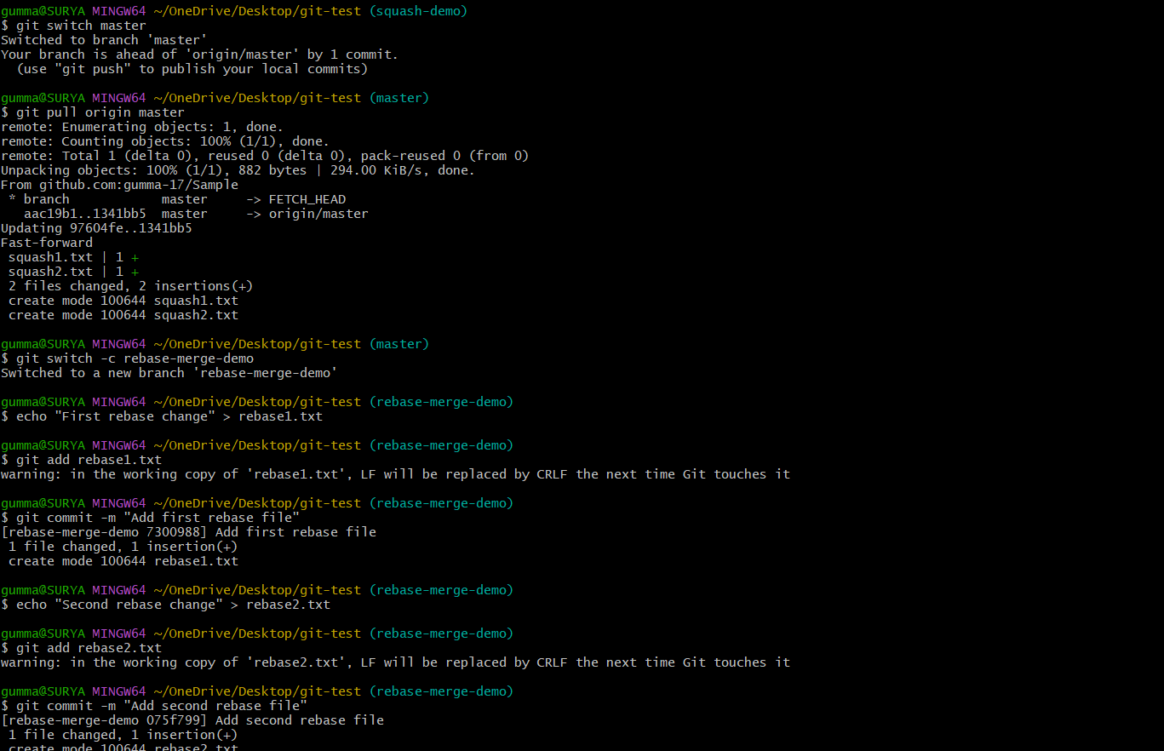

Step 6: Push and Create a Second Pull Request
git push -u origin rebase-merge-demo
Open a second pull request from rebase-merge-demo into master.
Select Rebase and merge, if enabled, and confirm the merge.
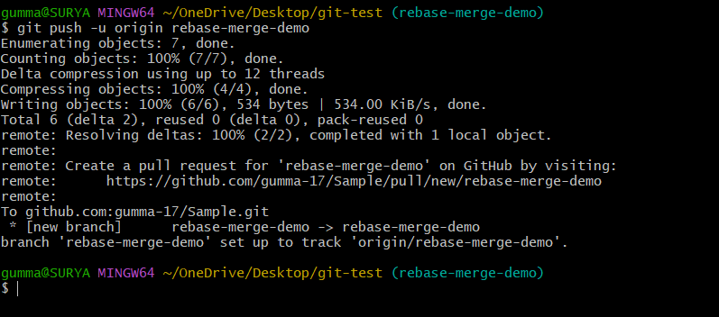
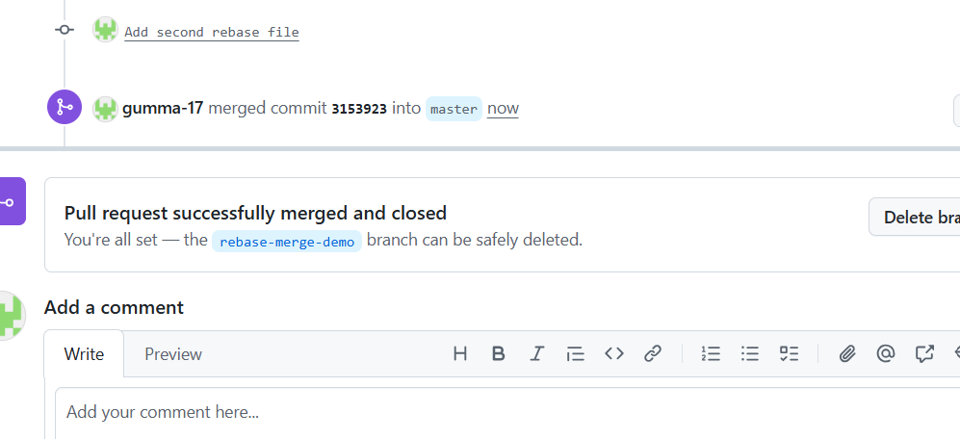

Step 7: Inspect the Commit History
Update your local base branch after the pull requests are merged:
git switch master
git pull origin master
git log --oneline --graph --decorate -15
Compare the commits associated with each pull request.
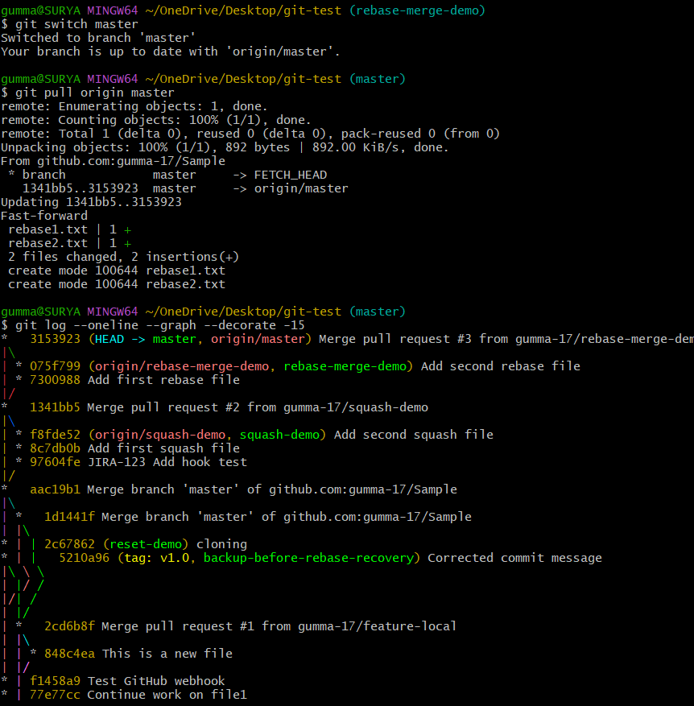

Validation Steps
No. | Test | Expected Result
1 | Create multiple commits on squash-demo | Multiple source commits appear.
2 | Squash-merge its pull request | Changes appear in one combined base-branch commit.
3 | Create multiple commits on rebase-merge-demo | Multiple source commits appear.
4 | Rebase-merge its pull request | Individual commits are applied to the base branch.
5 | Inspect the graph and commit messages | The different history outcomes can be observed.

Explanation
Squash merge combines the pull request's changes into a single commit on the base branch.
Rebase merge applies the pull request's individual commits onto the base branch without creating a merge commit.
Both methods can produce a linear history.
The exact merge options available depend on the repository's GitHub settings.

Real-Time Use Case
A team may use squash merge to keep the main branch concise, while rebase merge can be useful when preserving individual, meaningful commits from a pull request is important.

Common Errors and Troubleshooting
Error | Possible Cause | Solution
Merge strategy unavailable | Repository settings disable the strategy | Ask a repository administrator to check the allowed merge methods.
Pull request has conflicts | Base branch changed after the feature branch was created | Update the feature branch and resolve conflicts.
Push rejected | Remote branch has new commits | Fetch and integrate remote changes.
History looks different from expected | The wrong pull request merge method was selected | Inspect the pull request and base-branch history.

Conclusion
Squash merge and rebase merge were demonstrated using separate pull requests. Squash merge produced a single combined commit, whereas rebase merge preserved the individual commits on the base branch.

Task 13: Fork and Pull Request Workflow

Outcome
A repository was forked, cloned locally, modified on a feature branch, and submitted as a pull request to the original repository.

Objective
To understand how developers contribute to repositories they do not own by creating a fork and submitting proposed changes for review.

Prerequisites
- Git and Git Bash installed.
- A GitHub account.
- Internet access.
- A public repository that accepts contributions.
- Permission to create a fork under your account.

Step-by-Step Implementation

Step 1: Select an Original Repository
Open a public GitHub repository that you are permitted to contribute to.
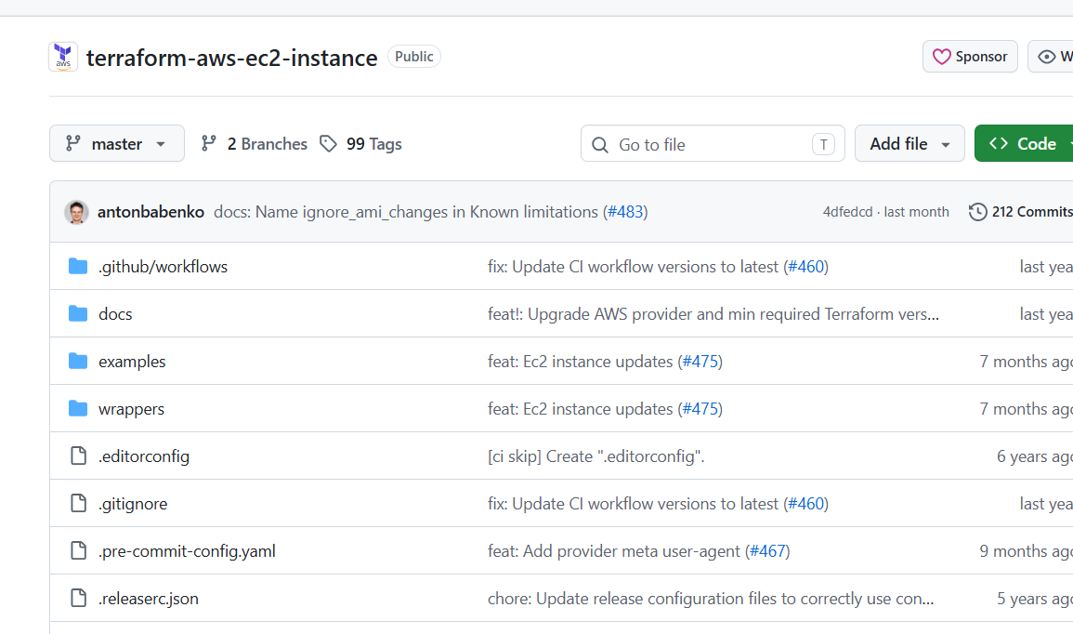

Step 2: Fork the Repository
Open the original repository page.
Click Fork.
Select your GitHub account as the owner.
Complete the fork creation process.

Step 3: Clone Your Fork
Replace YOUR-USERNAME and REPOSITORY with the actual values.
git clone https://github.com/YOUR-USERNAME/REPOSITORY.git
cd REPOSITORY

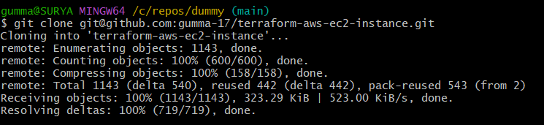

Step 4: Create a Feature Branch
git switch -c docs-improvement

Step 5: Modify a File
For example, add a line to an existing documentation file after checking its name:
ls
If README.md exists, you can append a test line:
echo "Documentation contribution test" >> README.md
git add README.md
git commit -m "Improve documentation"

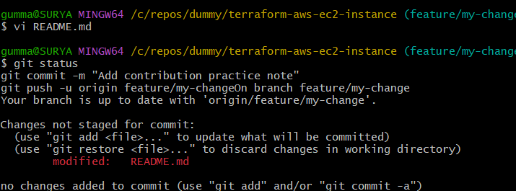

Step 6: Push the Feature Branch to Your Fork
git push -u origin docs-improvement

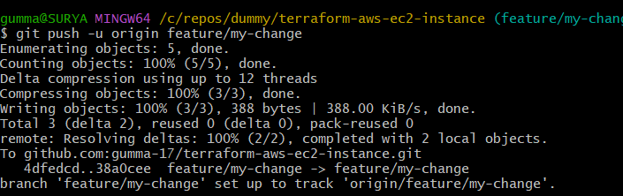

Step 7: Create a Pull Request
Open your fork on GitHub.
Select the docs-improvement branch.
Click Compare & pull request, or open the Pull requests tab and create a new pull request.
Confirm that the base repository is the original repository.
Confirm that the head repository is your fork.
Add a meaningful title and description.
Click Create pull request.
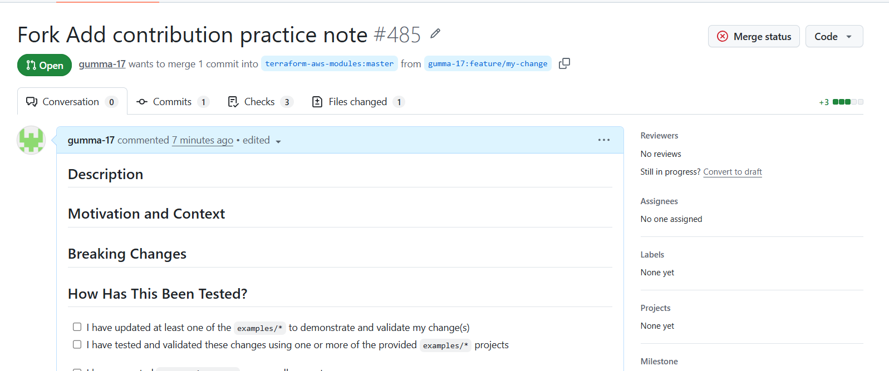

Step 8: Verify the Pull Request
Open the original repository's Pull requests tab and confirm that your proposed change appears.

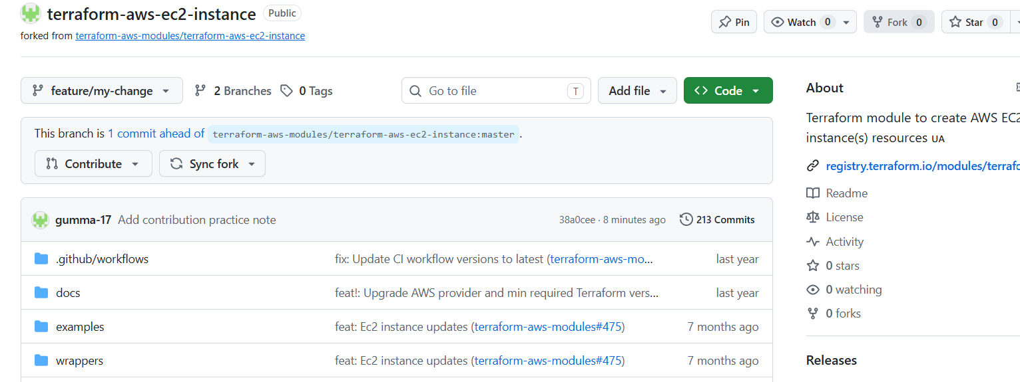

Validation Steps
No. | Test | Expected Result
1 | Fork the original repository | A copy appears under your account.
2 | Clone your fork | Local repository is created.
3 | Create a feature branch and commit a change | Commit is saved on the feature branch.
4 | Push the branch | Branch appears in your fork on GitHub.
5 | Submit the pull request | Proposed changes appear in the original repository's pull request list.

Explanation
A fork is a separate GitHub repository under another account.
git clone downloads a repository to the local computer.
A feature branch isolates the proposed contribution.
git push uploads the branch to your fork.
A pull request asks the original project's maintainers to review and potentially merge the proposed changes.

Real-Time Use Case
Open-source contributors use forks and pull requests to suggest bug fixes, documentation improvements, and new features without needing direct write access to the original repository.

Common Errors and Troubleshooting
Error | Possible Cause | Solution
Repository not found | Incorrect URL or private repository access is missing | Verify the URL and access permissions.
Push rejected | Insufficient access or remote changes | Confirm that origin points to your fork and check repository permissions.
Pull request targets the wrong repository | Base and head repositories were selected incorrectly | Select the original repository as the base and your fork as the head.
No changes appear in the pull request | Changes were not committed or pushed | Verify the branch history and push the feature branch.

Conclusion
A repository was forked and cloned, changes were committed on a separate branch, and a pull request was submitted to the original repository. This practical demonstrates the standard contribution workflow used in open-source development.

Task 14: Recover a Lost Commit Using Git Reflog

Outcome
A commit removed from the current branch history by git reset --hard was recovered using Git reflog.

Objective
To understand how Git reflog records recent movements of HEAD and how it can help recover commits that are no longer referenced by the current branch.

Prerequisites
Git and Git Bash installed.
A local Git repository.
A clean working tree.
Basic knowledge of commits and reset.
A disposable practice branch.

Step-by-Step Implementation

Step 1: Create a Recovery Branch
git switch -c reflog-recovery

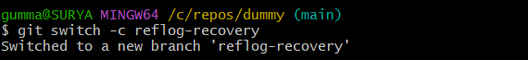

Step 2: Create the First Commit
echo "First recovery test" > lost.txt
git add lost.txt
git commit -m "First recovery commit"

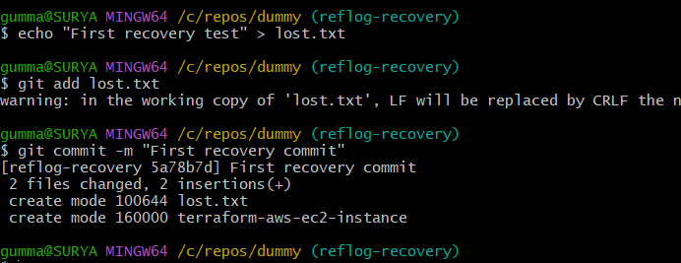

Step 3: Create the Commit to Recover
echo "Important work" >> lost.txt
git add lost.txt
git commit -m "Important commit to recover"

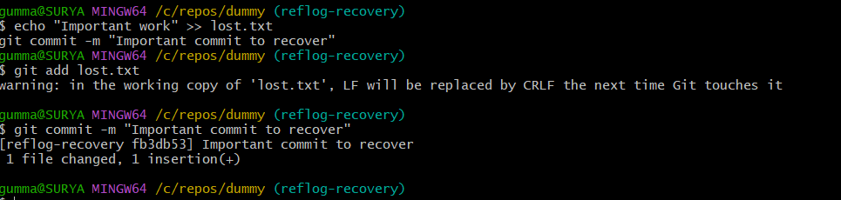

Step 4: Record the Commit Hash
git log --oneline -3
Copy the hash associated with Important commit to recover.
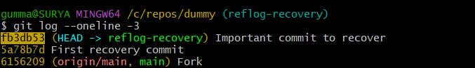

Step 5: Simulate Losing the Commit
git reset --hard HEAD~1
This moves the branch back one commit and resets tracked files. The second commit is no longer at the branch tip.
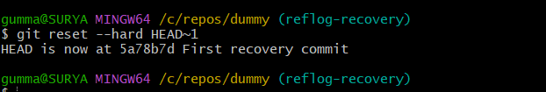

Step 6: Inspect Git Reflog
git reflog
Find the entry corresponding to Important commit to recover.
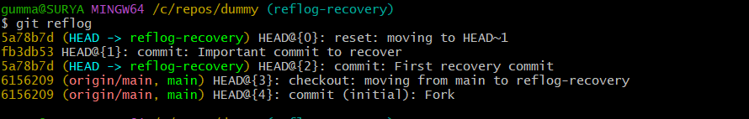

Step 7: Recover the Commit on a New Branch
Use the saved hash or the correct hash from reflog:
git branch recovered-commit <commit-hash>
git switch recovered-commit
Replace <commit-hash> with the actual commit hash.
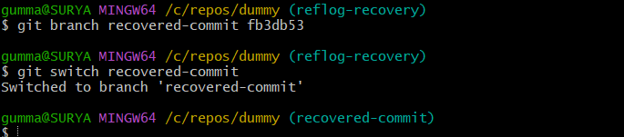

Step 8: Verify the Recovered Work
git log --oneline -5
cat lost.txt
git status
The recovered branch should contain the important commit and the associated file content.
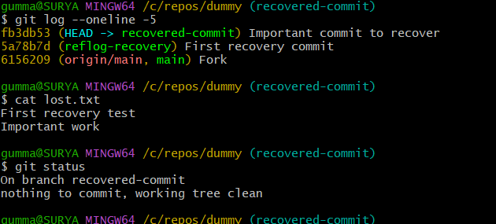

Validation Steps
No. | Test | Expected Result
1 | Create two commits | Both commits appear in history.
2 | Run git reset --hard HEAD~1 | The latest commit is removed from the current branch tip.
3 | Run git reflog | The earlier HEAD position is visible.
4 | Create recovered-commit at the saved hash | New branch points to the lost commit.
5 | Run git log --oneline -5 | The recovered commit appears in the branch history.
6 | Inspect lost.txt | The important content is restored.

Explanation
git reset --hard HEAD~1 moves the branch backward one commit and resets tracked files.
git reflog records recent changes to HEAD and other local references.
git branch can create a new branch pointing to a recovered commit.
Reflog entries are local and expire over time, so recovery should be attempted promptly.

Real-Time Use Case
A developer accidentally resets a branch and loses the visible reference to a completed commit. The reflog can help locate the commit and create a new branch to preserve the work.

Common Errors and Troubleshooting
Error | Possible Cause | Solution
Commit hash not found | Incorrect hash or expired reflog entry | Inspect the full reflog and copy the correct hash.
Recovered branch already exists | A branch with that name is present | Choose another name or inspect the existing branch.
File changes are missing | Wrong commit was selected | Locate the correct commit in reflog and recreate the branch.
Reflog entry is unavailable | Entry expired or commit object was removed | Check other branches, remote repositories, or backups.

Conclusion
A commit was removed from the current branch tip using git reset --hard and then recovered through Git reflog. This practical demonstrates how Git can help recover recent commits after accidental history changes.

